**Insurance Domain Project**

# **Terminologies used in Insurance Domain -**

**What is insurance…?**

* Insurance is defined as a contract, which is called as a policy, in which as individual or organization receives financial protection and reimbursement of damage from insurer to insurance company.

**Category of insurance -**

* Insurance category –

1. Health
2. Life
3. Business
4. Residence
5. Vehicle
6. Transport
7. Other

**Types of Insurance Policies-**

1. **Life insurance (Long term)**
2. Accidental death & dismemberment insurance
3. Disability insurance
4. Total permanent disability insurance
5. Long term care insurance
6. **General / Non-life insurance (Short term)**
7. Auto – (car, any vehicle)
8. Fire- Home, Car- It covers any damage to property because of a fire.
9. Liability- two vehicle accident case
10. Marine insurance
11. Transport insurance /communication insurance
12. Travel insurance
13. Satellite insurance
14. Vehicle insurance
15. **Other insurance**
16. Causality insurance
17. Group insurance
18. Liability insurance
19. Pet insurance
20. Crop insurance
21. Workers' compensation insurance
22. **Auto Insurance**
23. Two-wheeler insurance
24. Miscellaneous vehicle insurance
25. Car insurance

**Top 10 insurance companies in World-**

1. UnitedHealth Group Incorporated United States
2. AXA S.A. France
3. Anthem, Inc. United States
4. Allianz SE Germany
5. Centene Corporation United States
6. State Farm Group United States
7. Humana Inc. United States
8. Berkshire Hathaway Inc. United States
9. Munich Reinsurance Company Germany
10. Nippon Life Insurance Company Japan
11. Life Insurance Corporation of India India

**Some top insurance companies in India-**

1. LIC Insurance Corporation Of India.
2. ICICI Prudential Life Insurance.
3. SBI Life Insurance.
4. HDFC Standard Life Insurance.
5. Max Life Insurance.
6. Reliance Nippon Life Insurance.
7. TATA AIA Life Insurance.
8. PNB Metlife India Insurance.
9. Starhealth Insurance

# Domain Terminology in insurance -

* **Insurer-** Insurer is an insurance company selling the policy
* **Insured / Policy Holder**- An insured or policy holder is the person or entity buying the insurance.
* **Insurance coverage -** The term ‘insurance coverage’ means, when an individual takes an insurance policy the insurer will be covered by insurance company for a specific amount for themselves or the things that he had taken the insurance policy, for which he would be paying premiums to the insurance company.  The insurance company will pay the insured in case of damage or claims made by the insured according to their ‘insurance coverage’.
* **Premium / insurance rate -** It is factor used to determine the amount to be charged for a certain amount of insurance coverage called premium.
* **Claim-** It is the insurance benefit amount that is to be settled to the beneficiary as per the policy document.
* **Policy**- A written contract or an agreement between the insurance company and a policyholder. The policy document includes legal details/wording about what is included in the coverage and what is excluded from the policy coverage.
* **Underwriter -** Underwriter is a professional who analyses and classifies the risk for an insurance company. based on this assessment the decision is made as to whether to accept or reject the application.
* **Deductible-** It is the flat amount which an insured person needs to pay before the insurance company starts providing the policy benefits.
* **Co-Insurance**- After the deductible has been paid by an insured person, the insured person must pay a specific percentage of the billing amount (let’s say 20%) only then the insurer or insurance company will pay the remaining 80% of the amount.
* **Third Party Administrator (TPA)**- It is an individual or firm hired by an employer to deal with claim handling, claims to process. Intermediaries: Brokers, Agents etc.
* **Commission-** The amount to be paid by an insurance company to the agent who sold the policy.
* **Beneficiary-** The person who is entitled to get the policy benefits in case of unforeseen events.
* **In force-** Insurance policy on which the premium is fully paid.
* **Grace Period**- It is the time after the due date of the premium in which the policy remains in force.
* **Lapse-** It is the termination of the policy in case the premium amount is not being paid before the end of the grace period.
* **Contestable period-** ‘Contestable period’ is usually 1 or 2 years, during which the insurance company holds all the right to investigate the policy and decide whether to pay or not to pay to the insured.
* **No-claim bonus-** No claim bonus is a benefit for those who have not claimed insurance during the preceding year of cover. This will lower the premium on the following year.
* **Declaration page -** ‘Declaration page’ in insurance policy, bears all the information of the policy holder like name, address, vehicle information, type of coverage and loss payee information.
* **Cash value -** Cash Value’ is the cash amount offered to the policy holder while cancelling the policy, where a portion of the premium paid goes into saving plan. It is also referred as surrender value.  This term is normally used for life Insurance contract.
* **Surrender Value -** Surrender Value is the amount when you stop paying the premium and withdraw the entire amount. The policy ceases as soon as you withdraw the money, and the insured will lose out all the returns on it.
* **Paid Value -** The paid value is something when the insured stops paying the premium but do not withdraw the amount. The sum assured by the insurance company is reduced proportionally depending on when insured has stopped paying the premium.  You will get the amount at the end of the term.
* **Claim the policy-** To claim the policy, you must fill up the claim form and contact your financial advisor from whom you have bought the policy. You must supplement all the required documents like original payment receipt to your insurance company.  If everything is okey, you will be paid within seven days of the policy claimed.
* **Process Flow -**

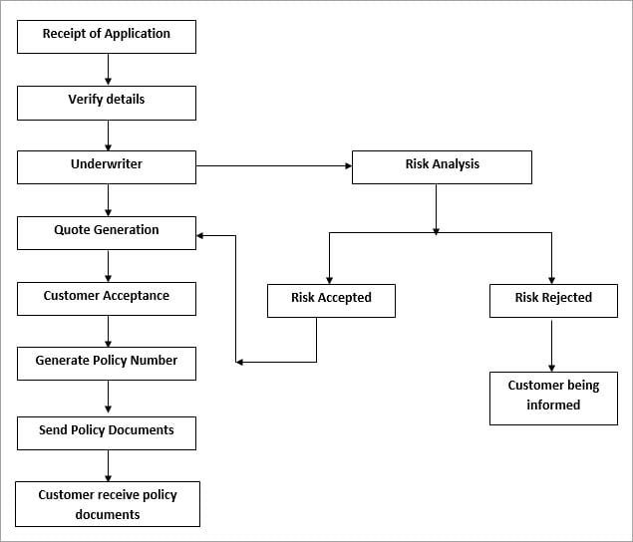

* **Basic Technical Flow -**

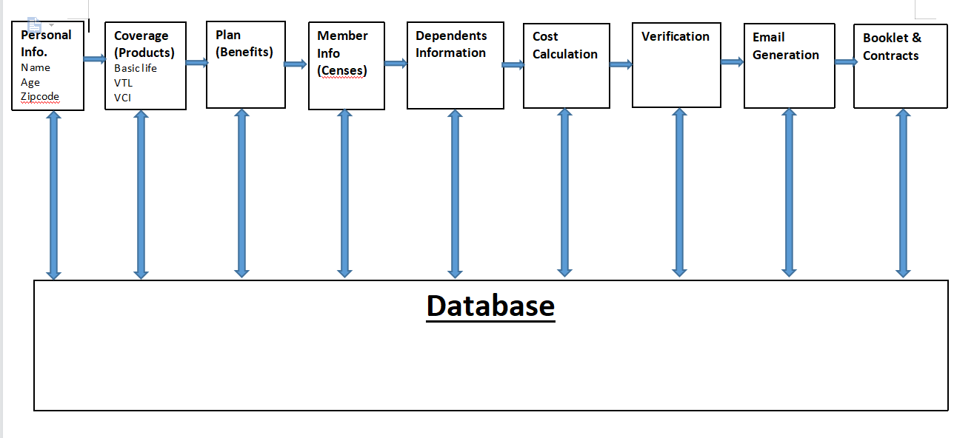

1. **Personal Info-**

In Technical Flow First of fall Policy holder need to create account with Personal info and Name of State for verification (SIC Number or Zip Code).

SIC - Standard Industrial Classification (4-digit code)

State Info required because of No. of Network available around the State.

Single and Group of people can be add through an Account as well as we can add the agents and agencies name from current State.

1. **Coverage-**

In Coverage Module Policy Holder need to select Respective Coverage with benefits available to it Coverage are nothing but Products on Which Client is give us Policy Term Insurance.

Some of the Name of Coverage’s-

1) Basic Life: One the Flu, small Viruses are qualified in that Policy.

2) Voluntary Term Life (VTL): These are the Policy Where we have short term diseases for claim.

3) Voluntary Critical illness (VCI): In VCI we can take all surgery type of diseases.

4) Accident: In these Coverage Accident can be claim.(any Bike and Car or vehicle Accident)

5) Dental: Dental is a Policy where we can add member single and multiple at a time.

6) Vision: Vision Involve the Total Test of Vision and Operation Coverage in Policy.

7) Short Term Disability (STD) and Long term Disability (LTD)

**C) Plan (Benefits)-**

Plan is medium where Policy holder can select the same plan more than Single time that gives an additional benefit to Policy Holder.

Plan Also Provides large benefits in Coverage with discount in Premium, Diff. Premium to every Person and Group

Plan gives more option to policy holder to select the no. of member should be Present in respective coverage with diff plan.

**D)Member & Dependent Info-**

Need to give of every member and it’s Dependent info Like Name, Relation with Policy Holder, age,

State, annual Income etc.

Note: For VTL, VCI and accident you need to add 5 members each coverage.

Dependent can be added According to number of member selected or Single member can also be dependent.

1. **Cost Calculation-**

Cost is calculated by auto robotic calculation system which Offer Premium according to selection of Coverage and no. of plan added in Policy.

1. **Verification-**

All the Documents and Premium records need to be validating by Company and according to that permission are granted by Client and Several government bodies.

Same Authority is going to validate during claim of Policy.

1. **Email Generation-**

Ones the all the verification is done then on official email is generated with proper document in it.

Without email generation there is no any policy premium is deducted.

Email consist of Premium date, Premium total Amount, Proposal number etc.

1. **Booklet & Contracts-**

Ones you Paid the Premium for Several month then you can see the booklet and contracts of your account.

Booklets & Contracts are nothing but the total amount you have paid until now. As well as you can also customize the Document according to you and coverage.

* **Different Layers of Insurance Domain Project in Company -**

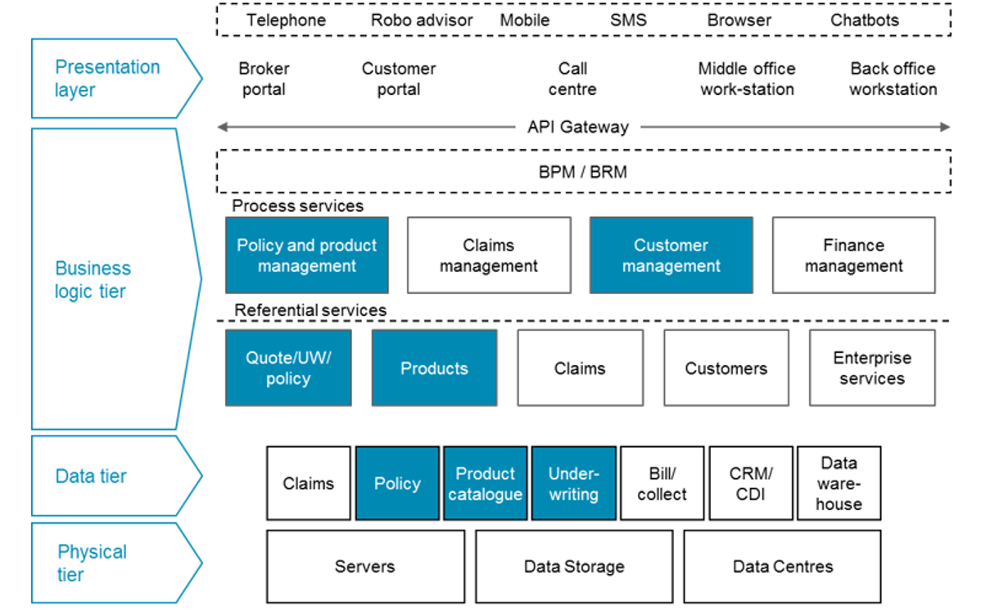

* **Business Model / Flow:**
* Basically Insurance Company has various module from which they can earn e.g Policy, claims ,Insurance ,Products & many other things.
* So owner of Company gain capital from these Policies and insurance by use of an web application.
* There are many persons who consulted the owner about policy and term payments.
* The Client Earn the money from charging premium in Exchange of coverage and Plan And that Premium amount are add into their assets of Profit making.
* **E.g :-** Suppose the Insurance company collect the premium of 5 million Dollar in which they give claim amount is 4 million Dollar then Client earn the profit of 1 Million Dollar.
* Profit Margin are distributed throughout the company by owner.
* Application is Design in such a way that it bring every possible life saving thing in term policies.
* To ensure a potential customer actually qualifies for an insurance policy. The applicant is key metrics like health, age, annual income, gender, and even credit history are measured, with the goal to have a premium cost level where the insurance company gains maximum advantage from a risk point of view.
* Brought Insurance for Family, Group as well as For Organization.
* **Technical Flow For Insurance Claim:**

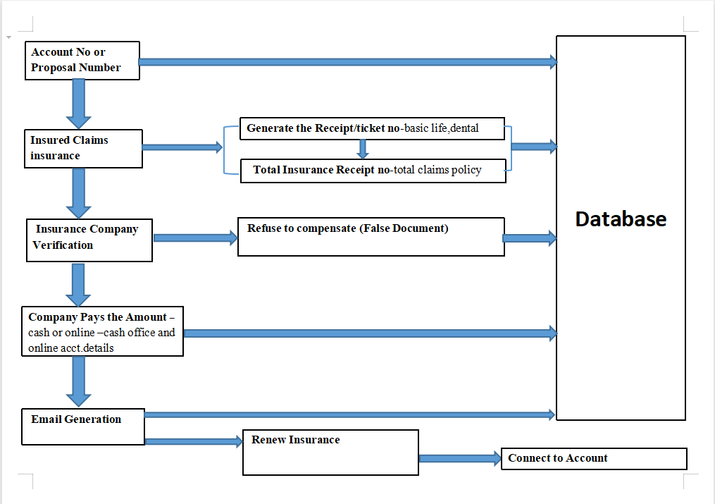

* **Account/ Proposal Number:**

As of from same account number we have to login and use Proposal number which generated at the end of completion of Policy.

Ones the login is Complete then we must select the claim Coverage.

* **Insured Claims insurance:**

Ones the Claim Coverage selected then total no. of coverage grant are available on UI with total amount of premium, no. of days, total amount for claim ,benefits of Premium.

For each and every coverage claim separate receipt is generate for database with diff. set of receipt number.

And for total no. of coverage claims are stored in database which is nothing but the set of coverage claim in respective Case.

* **Insurance Company Verification:**

With the given Case number we have to insured that the entire document submitted for coverage claims must be correct according Policy.

Important thing is ones the document submitted the verification is take for 24 hrs or more.

Document needed for the claims must have all the bills paid, proposal document, If agent is their then it’s registration number, national identification etc.

If the Document is false or incorrect regarding to Policy Company can withdraw the Claim immediately which nothing but (Refuse to Compensate).

Ones the verification is done it stored in a database and generates the scheme number.

* **Compensation (Company pays amount):**

Total Claim amount will be credited to give bank account details which are provided by Policy holder.

Ones the Amount Deducted from company it stored in Database (data entry) and generates Case Number regarding to the Policy holder to whom company has paid the claim amount.

* **Email Generation:**

Ones the all the verification & amount is deducted then on official email is generated with proper document in it.

These entries are stored in database.

* **Renew The Policy:**

After Claim Process is completed the policy holder can apply for renew the same policy or can apply for another policy with same account details.